
ACE ENGINEERING, GATHKESAR
(An Autonomous Institute under JNTU, Hyderabad)
DEPARTMENT OF COMPUTER SCIENCE ENGINEERING(IOT)

EBOX: PROJECT

Presentation
on

FREELANCER MARKETPLACE
Connecting Clients and Freelancers Globally

Guide:
MR.KRISHNANAND

Presented by :
B. VAMSHI (21AG1A6908)
K. SUSHMITHA (21AG1A6935)
P. MANI GAYATHRI (21AG1A6949)

CONTENTS:
- Introduction
- Workflow Overview
- Functional Requirement
- ER Diagram
- Challenges and solutions

INTRODUCTION
- What is a Freelancer Marketplace?
- An online platform connecting clients with freelancers.
- Facilitates project posting, proposal submission, contract formation, and reviews.
- A freelancer is an independent professional who offers specialized services to clients on a project-by-project basis rather than being employed by a single organization.

Workflow Overview
- Project Posting: Client posts a project.
- Proposal Submission: Freelancers submit proposals.
- Proposal Review: Client reviews and selects a proposal.
- Contract Formation: Contract is established.
- Project Execution: Freelancer works on the project.
- Payment & Completion: Payment is released upon completion.
- Review & Rating: Both parties leave reviews.

Functional Requirements for Freelancer Marketplace

Project Management:
Post projects: Title, description, budget, timeline.

Proposal Management:
Submit proposals: Bid amount, approach. Review and select proposals.

Contract Management:
Form contracts: Project details, payment terms. Track contract status.

Communication Tools:
Built-in messaging.
File attachments and notifications.

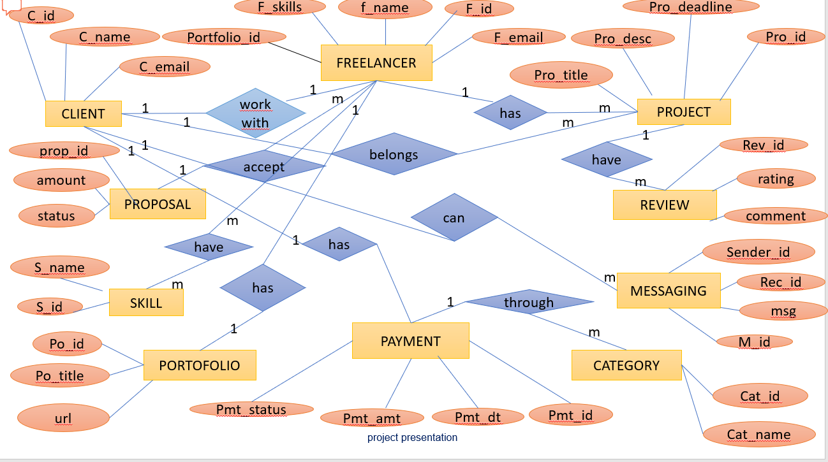

Challenges and Solutions

Challenges:
    - Miscommunication
    - payment issues
    - quality assurance.

Solutions:
    - Clear contracts
    - milestone payments
    - review systems.

Thank you

